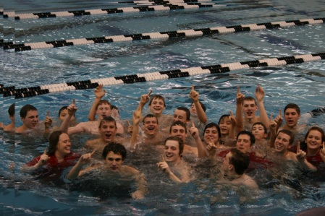

Chippewa Valley High School

2012-2013 Varsity Boys Swim & Dive
HEAD COACH: Tony Grice ASSISTANT COACH: Suzanne Murray
DIVING COACH: Steve Morrow

http://cvhs-swimboys.weebly.com <<<<< Check us out online
Mr. & Mrs. Sample Letter Insert Date

Hello, My name is ____________ (son of ) and I need your help.

- Our Swim Team Budget is $800.00 short and we are looking for sponsors / donations.

- 34 swimmers are diligently trying to raise money before January 31st 2013 deadline.

- Our Fundraiser Program Efforts have not been enough.

Swim Budget Covers
- Assistant Coach’s Salary
- Senior Night
- Year End Awards / Trophies
- Program, Gifts & Decorations for Banquet
- Championship T-Shirts
- Swim suits / Jammers

****Any size donation would be greatly appreciated.****

Please Make Checks Payable To: C V H S Boys Swim & Dive Team
For Tax Purposes:
School’s Tax I.D.# 386034009

Mail To: Chippewa Valley High School
Athletic Dept. / Boys Swim & Dive Team
18300 Nineteen Mile Road
Clinton Township, Michigan 48038

Thank-you for reading my letter,

___your name_______________

